Оглавление

Задание 1. 2

Задание 2. 3

Задание 3. 5

Задание 4. 7

Задание 5. 8

Ссылка на GitHub 9

# Задание 1.

package trainingTask3.p1;  
  
public class MainClass{  
 public static void main(String[] args){  
 System.*out*.println(InstructionsSQL.*getInstruction*("Group1", 3));  
 }  
}  
  
class InstructionsSQL{  
 static String getInstruction(String group,int dolg){  
 String instruction = new String();  
  
 instruction = "INSERT INTO T_GroupSelected (id_Student, firstName, lastName, id_Group) " +  
 "SELECT id_Student, firstName, lastName, id_Group FROM T_Student " +  
 "WHERE id_Group = '" + group + "' AND dolgCount > "+ dolg;  
 return instruction;  
 }  
  
}

Результат выполнения:



# Задание 2.

package trainingTask3.p2;  
  
public class MainClass2{  
 public static void main(String[] args){  
 Person p1 = new Person();  
 Person p2 = new Person();  
 Person p3 = new Person();  
 Person p4 = new Person();  
  
 p1.setFirst_name("Иван");  
 p1.setLast_name("Иванов");  
 p1.setTrird_name("Иванович");  
  
 p2.setLast_name("Иванов");  
 p2.setTrird_name("Алексеевич");  
  
 p3.setFirst_name("Петр");  
 p3.setLast_name("Иванов");  
  
 p4.setLast_name("Иванов");  
  
 System.*out*.println(p1.getFIO());  
 System.*out*.println(p2.getFIO());  
 System.*out*.println(p3.getFIO());  
 System.*out*.println(p4.getFIO());  
 }  
}  
  
class Person{  
 private String first_name;  
 private String last_name;  
 private String third_name;  
  
 public String getFirst_name() {  
 return first_name;  
 }  
  
 public void setFirst_name(String first_name) {  
 this.first_name = first_name;  
 }  
  
 public String getLast_name() {  
 return last_name;  
 }  
  
 public void setLast_name(String last_name) {  
 this.last_name = last_name;  
 }  
  
 public String getTrird_name() {  
 return third_name;  
 }  
  
 public void setTrird_name(String third_name) {  
 this.third_name = third_name;  
 }  
  
 String getFIO(){  
 String fio = last_name;  
 if (first_name == null && third_name == null) return fio;  
 else fio += " ";  
 if (first_name != null) fio += last_name.charAt(0)+".";  
 if (third_name != null) fio += third_name.charAt(0)+".";  
 return fio;  
 }  
  
}

Результат выполнения:

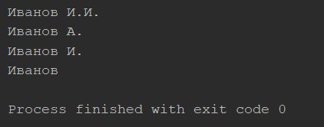

# Задание 3.

package trainingTask3.p3;  
  
import java.util.StringTokenizer;  
  
public class MainClass3 {  
 public static void main(String[] args){  
 Address adr1 = new Address();  
 adr1.setPartsComma("СтранаX, регион-, городA, улица 1, строение.7, корпус 44; ,квартира 12");  
 System.*out*.println(adr1.toString());  
  
 Address adr2 = new Address();  
 adr2.setPartsAny("Страна2, регион+, город B, улица 2, строение7, корпус 12, квартира 45");  
 System.*out*.println(adr2.toString());  
  
 Address adr3 = new Address();  
 adr3.setPartsAny("Страна#. регион*. город C; улица3, строение 7. корпус 3 ; квартира 23");  
 System.*out*.println(adr3.toString());  
  
 Address adr4 = new Address();  
 adr4.setPartsAny("Страна sdf; регион/, город D, улица 5, строение.7, корпус4; -12");  
 System.*out*.println(adr4.toString());  
 }  
}  
  
class Address{  
 private String name;  
 private String country;  
 private String region;  
 private String city;  
 private String street;  
 private String building;  
 private String block;  
 private String room;  
  
 public String getName() {  
 return name;  
 }  
  
 public void setName(String name) {  
 this.name = name;  
 }  
  
 public void setPartsComma(String str){  
 String[] words = str.split(",");  
 country = words[0].trim();  
 region = words[1].trim();  
 city = words[2].trim();  
 street = words[3].trim();  
 building = words[4].trim();  
 block = words[5].trim();  
 room = words[6].trim();  
 }  
  
 public void setPartsAny(String str){  
 StringTokenizer words = new StringTokenizer(str,",.;");  
 this.country = words.nextToken().trim();  
 this.region = words.nextToken().trim();  
 this.city = words.nextToken().trim();  
 this.street = words.nextToken().trim();  
 this.building = words.nextToken().trim();  
 this.block = words.nextToken().trim();  
 this.room = words.nextToken().trim();  
 }  
  
 @Override  
 public String toString() {  
 return "Address{" +  
 "country='" + country + '\'' +  
 ", region='" + region + '\'' +  
 ", city='" + city + '\'' +  
 ", street='" + street + '\'' +  
 ", building='" + building + '\'' +  
 ", block='" + block + '\'' +  
 ", room='" + room + '\'' +  
 '}';  
 }  
}

Результат выполнения:



# Задание 4.

package trainingTask3.p4;  
  
public class Shirt {  
 private String id;  
 private String description;  
 private String color;  
 private String size;  
  
 public static void main(String[] args){  
 String[] shirts = new String[11];  
 shirts[0] = "S001,Black Polo Shirt,Black,XL";  
 shirts[1] = "S002,Black Polo Shirt,Black,L";  
 shirts[2] = "S003,Blue Polo Shirt,Blue,XL";  
 shirts[3] = "S004,Blue Polo Shirt,Blue,M";  
 shirts[4] = "S005,Tan Polo Shirt,Tan,XL";  
 shirts[5] = "S006,Black T-Shirt,Black,XL";  
 shirts[6] = "S007,White T-Shirt,White,XL";  
 shirts[7] = "S008,White T-Shirt,White,L";  
 shirts[8] = "S009,Green T-Shirt,Green,S";  
 shirts[9] = "S010,Orange T-Shirt,Orange,S";  
 shirts[10] = "S011,Maroon Polo Shirt,Maroon,S";  
 Shirt[] realShirts = new Shirt[11];  
 for (int i=0; i<11; i++){  
 realShirts[i]=new Shirt();  
 realShirts[i].initShirt(shirts[i]);  
 System.*out*.println(realShirts[i].toString());  
 }  
 }  
  
 public void initShirt(String str){  
 String[] words = str.split(",");  
 id = words[0].trim();  
 description = words[1].trim();  
 color = words[2].trim();  
 size = words[3].trim();  
 }  
  
 @Override  
 public String toString() {  
 return "Shirt{" +  
 "id=" + id +  
 ", description='" + description + '\'' +  
 ", color='" + color + '\'' +  
 ", size='" + size + '\'' +  
 '}';  
 }  
}

Результаты выполнения:

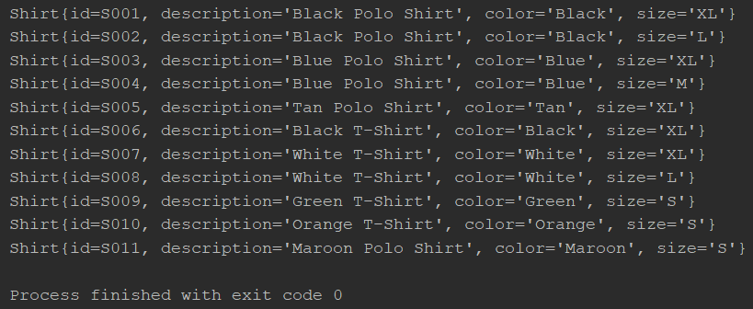

# Задание 5.

package trainingTask3.p5;  
  
public class Phone {  
 public static void main(String[] args){  
 String phone1 ="+79175655655";  
 String phone2 ="+104289652211";  
 String phone3 ="89175655655";  
 System.*out*.println(Phone.*formatPhone*(phone1));  
 System.*out*.println(Phone.*formatPhone*(phone2));  
 System.*out*.println(Phone.*formatPhone*(phone3));  
 }  
  
 static String formatPhone(String str){  
 String newPhone = new String();  
 if (str.charAt(0)=='+'){  
 newPhone = str.substring(0,str.length()-7)+"-"+str.substring(str.length()-7,str.length()-4)+"-"+str.substring(str.length()-4);  
 } else {  
 newPhone = "+7"+str.substring(1,str.length()-7)+"-"+str.substring(str.length()-7,str.length()-4)+"-"+str.substring(str.length()-4);  
 }  
 return newPhone;  
 }  
}

Результаты выполнения:

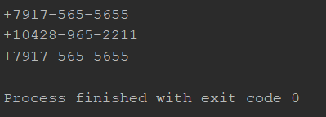

# Ссылка на GitHub

[yagorkas/Training-Tasks (github.com)](https://github.com/yagorkas/Training-Tasks)